**Experiment No 4**

**Shashwat Tripathi  
D15A 64  
Batch C**

**AIM: To install Kubectl and execute Kubectl commands to manage the Kubernetes cluster and deploy Your First Kubernetes Application.**

* **Running the application on the cluster**

kubectl create deployment nginx --image=nginx

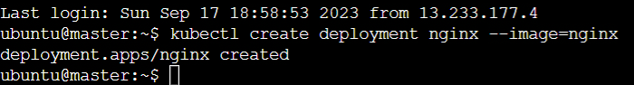

* **Verifying the deployment using command**

kubectl get deployments

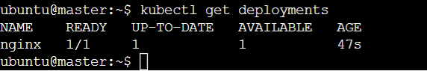

* **Run the following command to create a service named nginx that will**

**expose the app publicly.**

kubectl expose deploy nginx –port 80 –target-port 80 –type NodePort



* **Run this command to see the summary of the service and ports exposed.**

kubectl get services

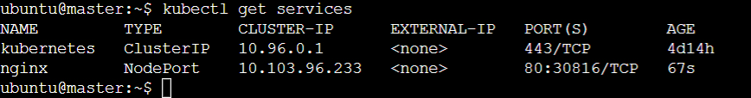

* **Add the port which is displayed i.e 30816 (will differ for each device) in the inbound rules of the security group of the worker.**

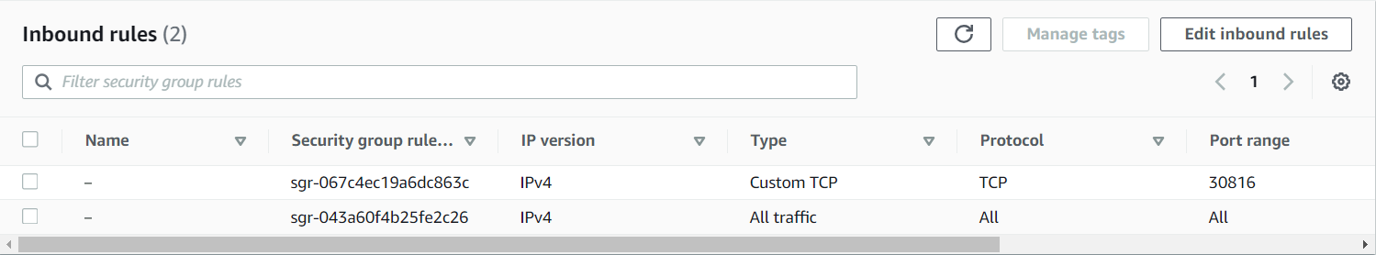

* **We can verify that the nginx page is accessible on all nodes using curl command(Worker)**

1. sudo su
2. curl worker:30816

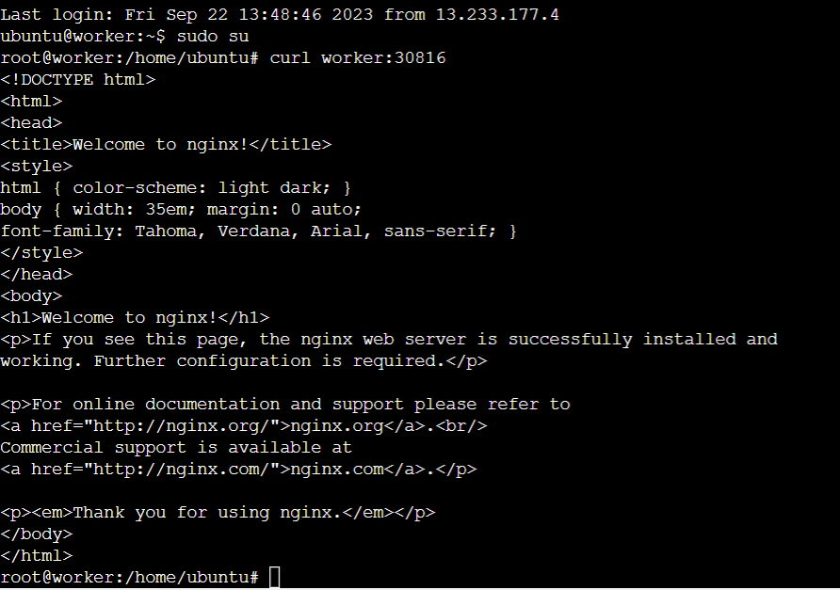

**Open a new tab in browser and paste the public IP address followed by :port number (30816 in my case)**

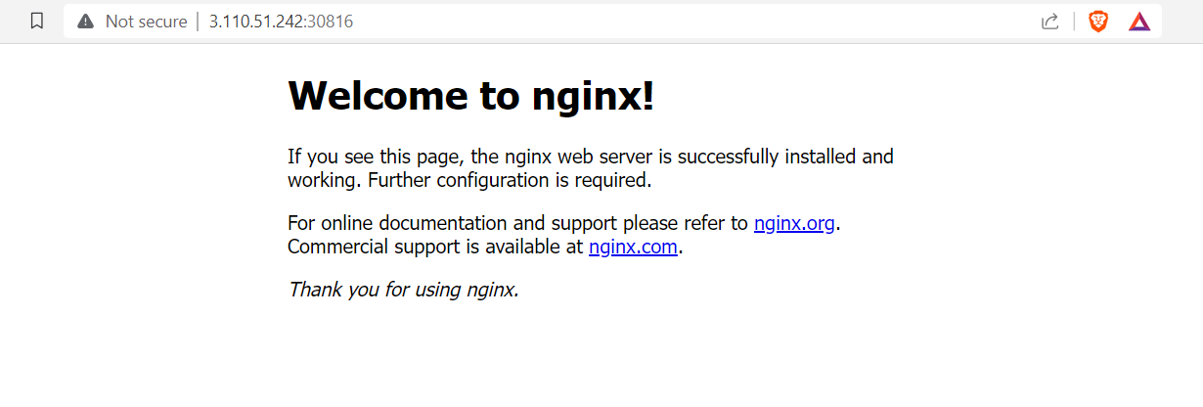

**Conclusion:**Thus, we have studied and implemented how to install Kubectl and execute Kubectl commands to manage the Kubernetes cluster and deploy.

**Errors:**

I was facing an error because I forgot to make changes in the security group of worker node.